

**A Trusted Business Card:**

**Demonstrating Supply Chain Defenses**

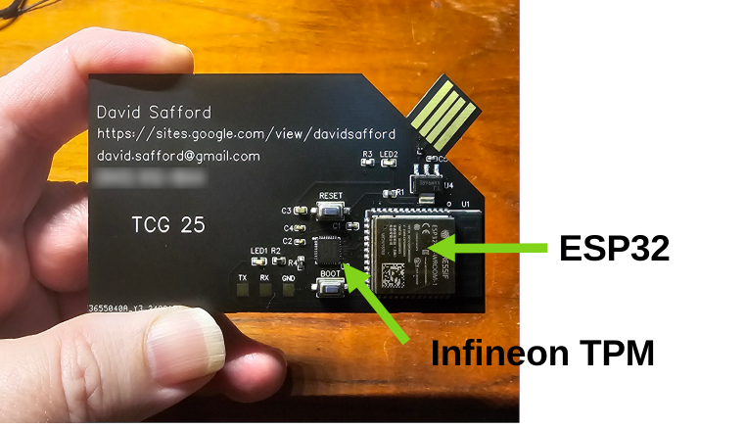

How do you know if your device is authentic and untampered?

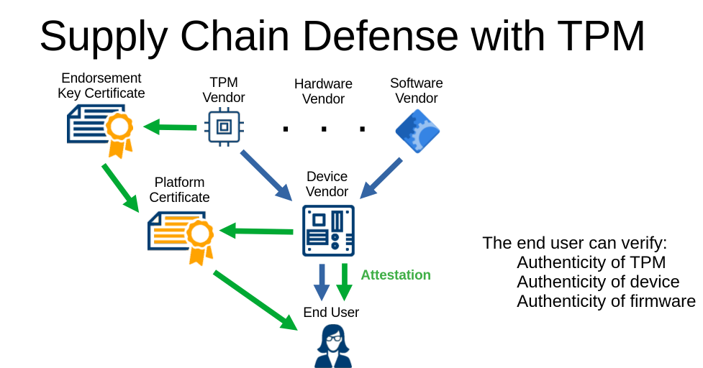

This is a fun and fast demonstration of how TCG standards can be used for supply chain defense.

Cards will be given away to the first twenty attendees who ask.

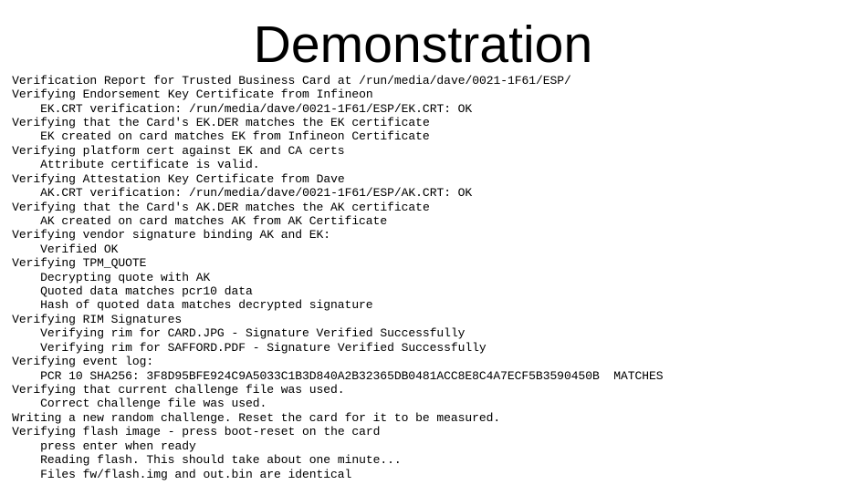

This is an open source, open hardware project, with all details at:

github.com/safforddr/tbc